KOALA Instructions

Check PyCharm Version
Make sure you are using the latest stable release of the PyCharm IDE (version 2025.3.3 as of March 8, 2026)
To check this:
- Click on the to open the Main Menu
  - On Mac, this will be in the top menu bar in PyCharm -> About PyCharm.
- Go to on Help -> About to get the below pop-up:
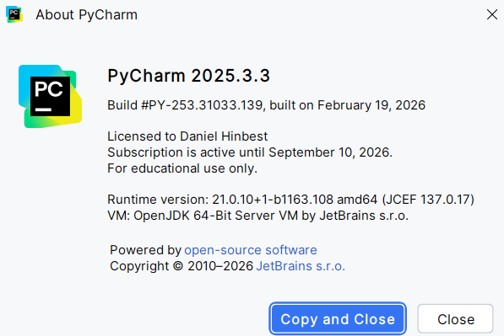
If it is not up-to-date, update your PyCharm installation by doing the following:
- Click on the to open the Main Menu
- Go to Help -> Check for Updates…
  - On Mac, this will be on the top menu bar
If you receive the following pop-up on the bottom of your screen, your PyCharm is already up-to-date:
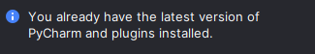

Installing KOALA
To install KOALA, go to the Google Drive link provided to you.
- Download the koala.zip file and save it in a location where you can easily find it
Open your course project in PyCharm and install the plugin.
- Click on the icon and select Plugins… to open the Plugins menu
- Click on the icon in the Plugins menu and select Install Plugin from Disk…
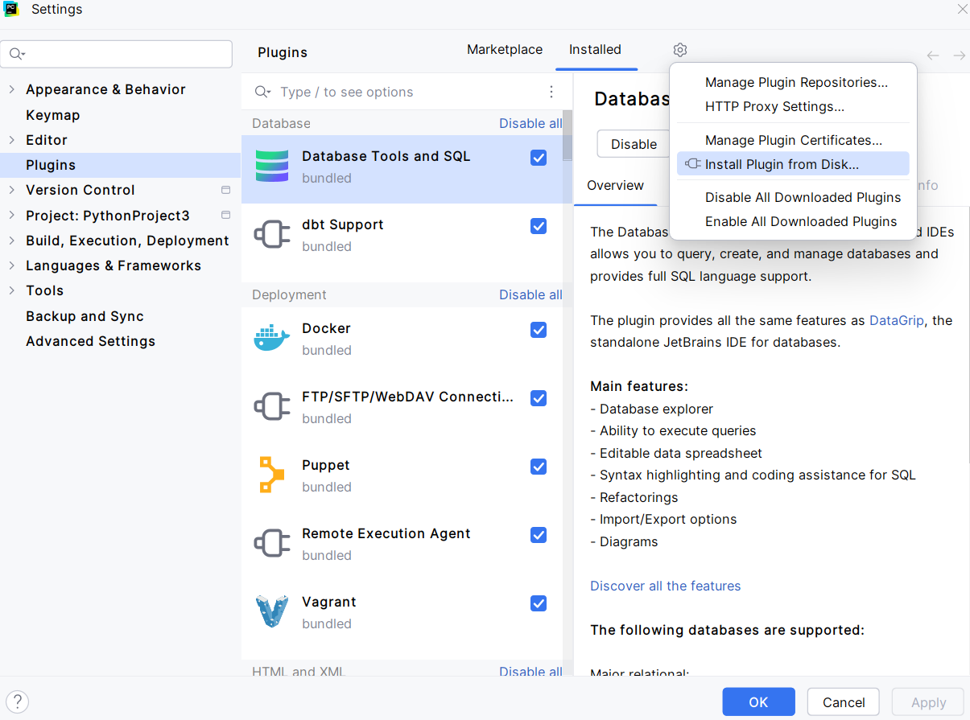

- Locate koala.zip in the file explorer and click OK
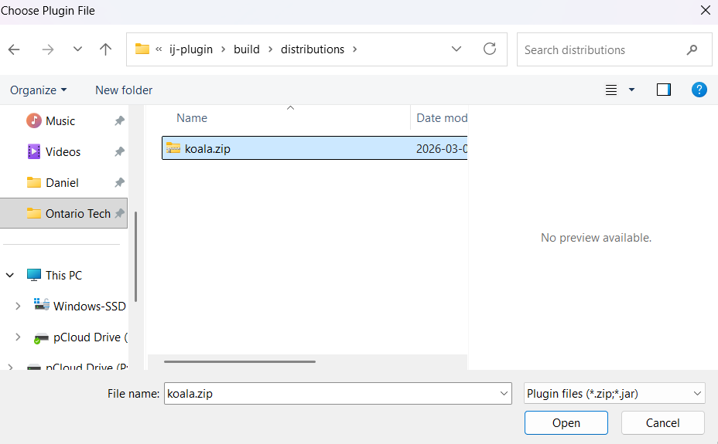
- Click Open, and Restart IDE on the Plugins window to install KOALA
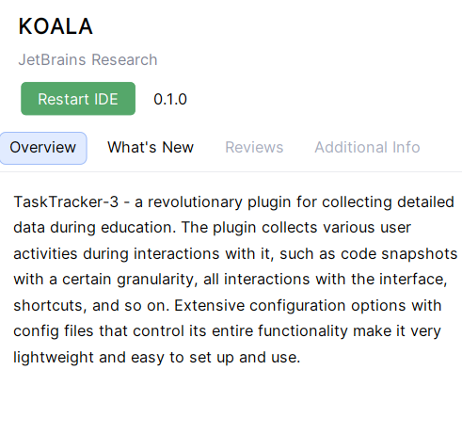
- After a few moments, you should receive a prompt to restart PyCharm to complete the installation. Click Restart to proceed.
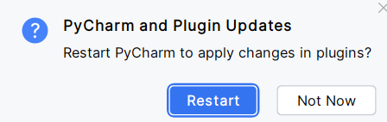
- After restarting, KOALA will be installed.

Using KOALA

Survey

Once KOALA is installed, it will be accessible on the right side of PyCharm and can be found with this icon and will look like the image below:
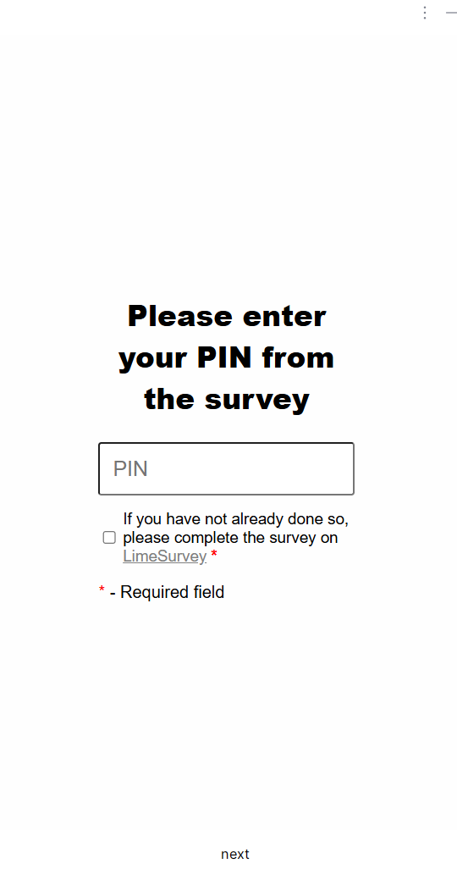
- In the first screen, you will be asked to enter your PIN from the survey you completed earlier. Please enter it in the field above and click next.

- The second screen is an explanation of purpose of the activity, review this and click next when you’re ready
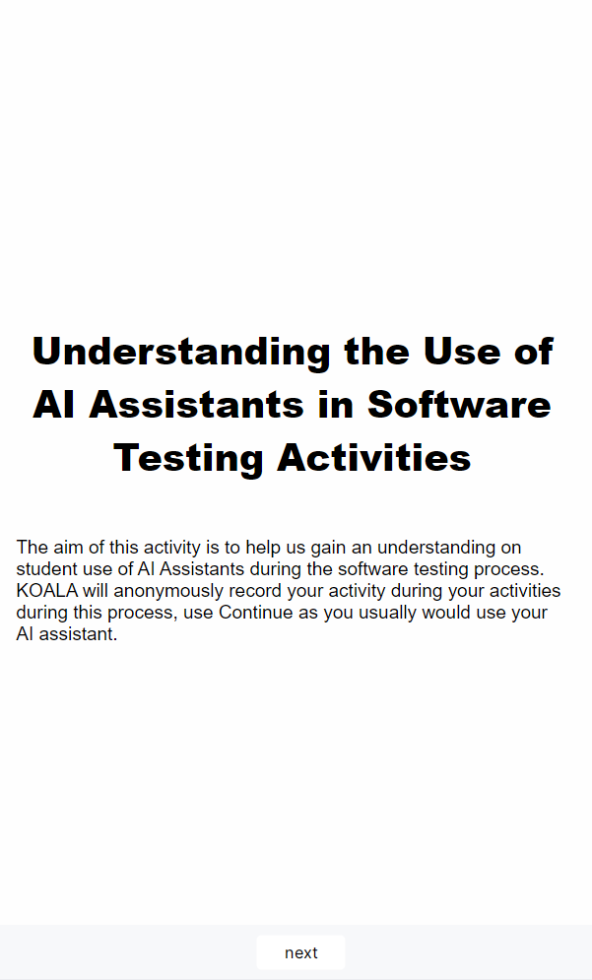

Tasks
The next screen you will see is Task Selection screen. There are three tasks to complete and they are focused on two forms of code coverage you have seen in the course – statement and branch coverage and should be completed in order. This screen will tell you what task you will be working on.
- When you are ready to start the tasks, click next
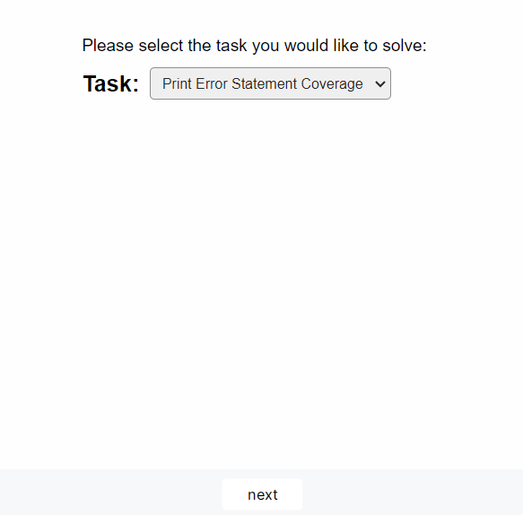

Sample Task
- The sample task is a simple example of what statement coverage could look like with a calculator program. It serves as a basic reference of what unit tests should generally look like using pytest. Your tests should be more detailed than these.
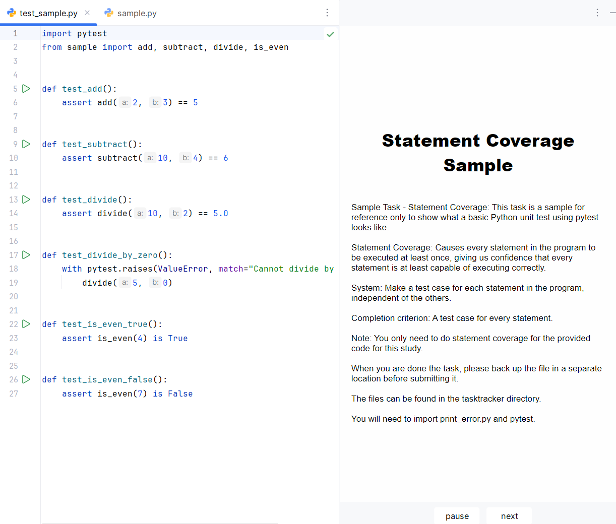

Solving a Task
- When you are solving a task, please prevent leaving comments such as your name and student number and write your code below the comment # Write your code here
- You can write and execute the code without interruption, and can also use Continue as you usually would with an AI Assistant
- The starter code, which is the same as the starter code provided for Phase 4 will also be provided for you and available in another tab.
NOTE: When you are done the task, please make sure to back up your file in a separate location before submitting it. The files can be found in the tasktracker directory in the root of the project.

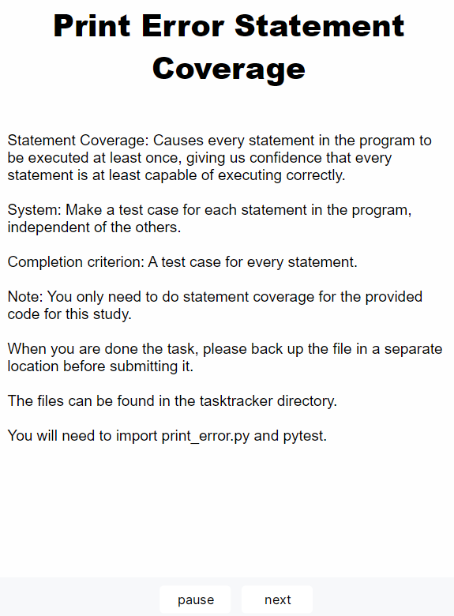
To submit the code, click next in KOALA. This will return you to the task selection. Repeat this process for all three tasks.

Uninstalling KOALA
Once the tasks have been completed, you can uninstall KOALA.
- Click on the icon at the top of PyCharm and select Plugins… and switch to the Installed tab
You will see KOALA in the list of plugins
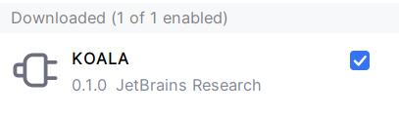
- On each of the plugins, click the and select Uninstall
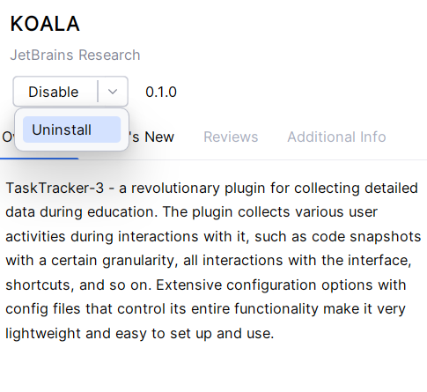
After the plugin has been uninstalled, click on Restart IDE and then Restart to complete the uninstallation process.
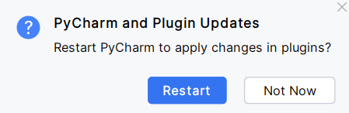
Click Restart to restart PyCharm. When it reloads, KOALA will be removed from PyCharm.

